Pipeline Explosion September 10, 2018 and the Subsequent Impact
My name is Barbara Goblick. This is Karen Gdula and Tom Coates, my neighbors. We represent the residents of Ivy Lane and Pine Street, Beaver County. This is where the Revolution pipeline exploded on September 10, 2018. Here is Karen with our story.
As a child I had a reoccurring nightmare that the woods behind my house were on fire. I now own the house my parents built. On September 10th, my childhood nightmare became reality.
Energy Transfer’s twenty-four-inch pipeline exploded after being operational for seven days. The Rosati’s, living closest to the site, ran out the door with only the clothes on their backs. The woman wanted to go back for a dog. The man said RUN. As they made their way up their driveway, they looked back, and flames were on their roof. They lost everything.
911 had to be convinced that a pipeline exploded; emergency personnel did not know it was operational. Neighbors helped neighbors as we evacuated. One made rope leashes for the Rosati dogs. Another gave them a vehicle. Words were few. Terror was in our eyes and on everyone’s face. An ambulance evacuated an at-home hospice patient. A young couple, on their way to give birth to their third child, heard about the explosion. They had to decide – return home to help with the other two children or have faith in emergency responders.
We sheltered at the local fire hall, waiting and wondering. The forest was rain soaked and slowed the flames. Uncharacteristically, the winds shifted and blew away from our homes. It was not our day to lose everything. It was not our day to die.
When we got the okay to return, we had no idea what we were about to endure. Homes suffered damage, mostly cracks in walls, ceilings and foundations.
Our quiet cul-de-sac quickly became a tourist attraction. Strangers disrespected us and our property. We called the police often.
Eleven high tension towers were damaged or destroyed. The roar of construction equipment, constant utility traffic, and helicopters overhead doing repairs became unbearable.
Traffic keeps coming, and reclamation equipment works to control erosion, springs and landslides. DEP inspection reports list violation after violation. DEP report 2835037 - “The area does not appear capable of resisting erosion.”
DEP stopped all new permits for Energy Transfer on February 8th. For now, the pipeline is not operational. We dread the day when construction resumes and gas flows again. We do not feel safe.
A second pipeline is under construction by National Fuel, headed to the Cracker Plant. It crosses the Energy Transfer pipeline a few hundred feet from the explosion site, on the same slope that is classified as ‘High Erosion Hazard’. I’ve talked to the PUC, DEP and local officials and they were surprised about this crossing. Where is the oversight?
No neighborhood should have to endure what Ivy Lane is going through. Pennsylvanian’s look to officials to make decisions to keep them safe. We respectfully request your support of pipeline safety legislation, before another explosion occurs, and this time someone dies.
It is difficult to summarize the intensity of the situation in a few minutes. Since September, this has evolved and become much bigger. There is more to this story below the surface. Thank you for your time, attention, and interest in our story.

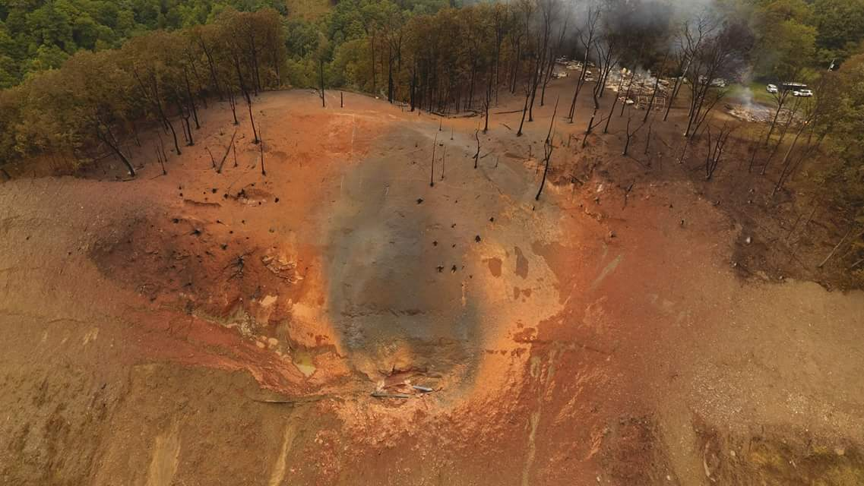
09-10-18 The explosion site the day of the incident. The separated pipe is circled. The destroyed house and garage are smoldering in the upper right corner.
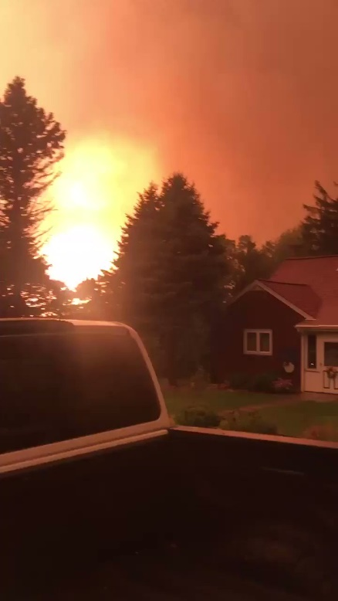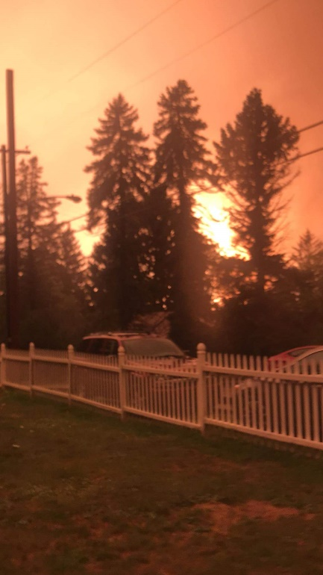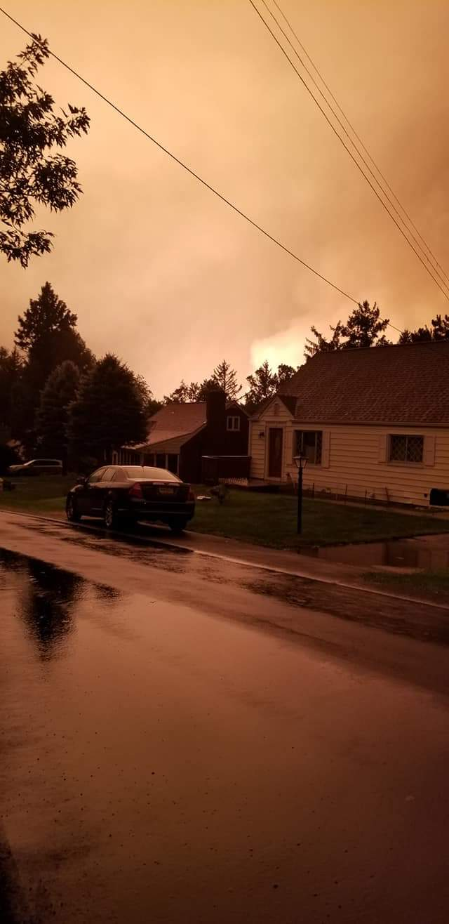
09-10-18 Our neighborhood, moments after the explosion. At 5:00 a.m. it looked like daylight.

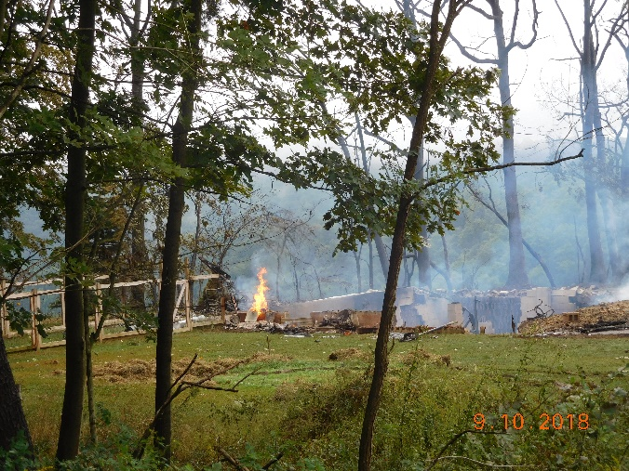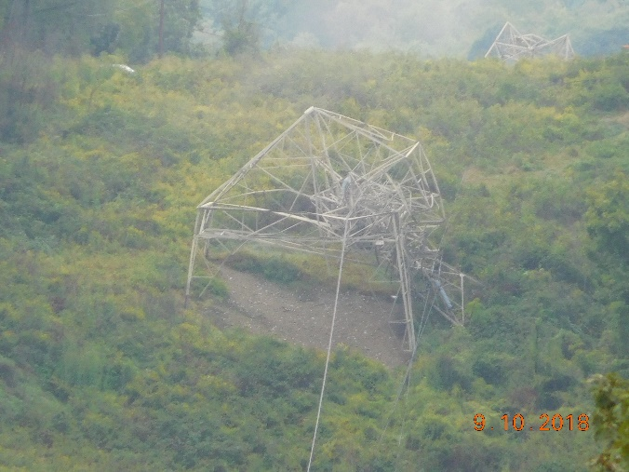
09-10-18 The destroyed house. 09-10-18 Two downed electrical towers.
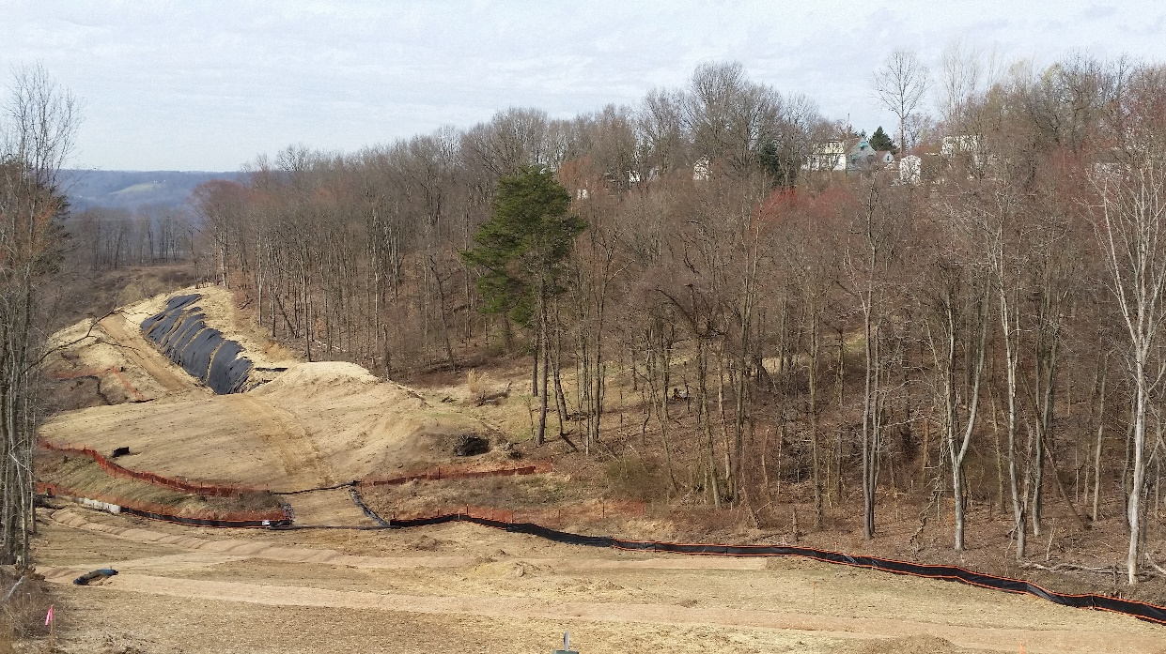
04-07-19 This is the pipeline route and entry to the explosion sight. Ivy Lane is on the right. Dirt piled high is hindering water drainage from our back yards.
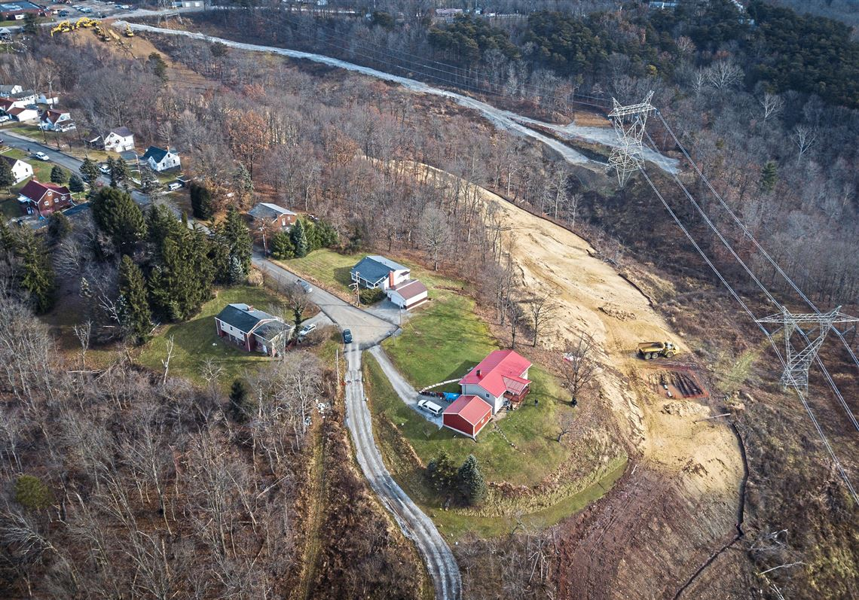
December 2018, photo by Andrew Rush, Pittsburgh Post-Gazette. National Fuel and Energy Transfer cross behind the red-roofed house on Ivy Lane, a few hundred feet from the explosion site, on land that is “High Erosion Hazard”.
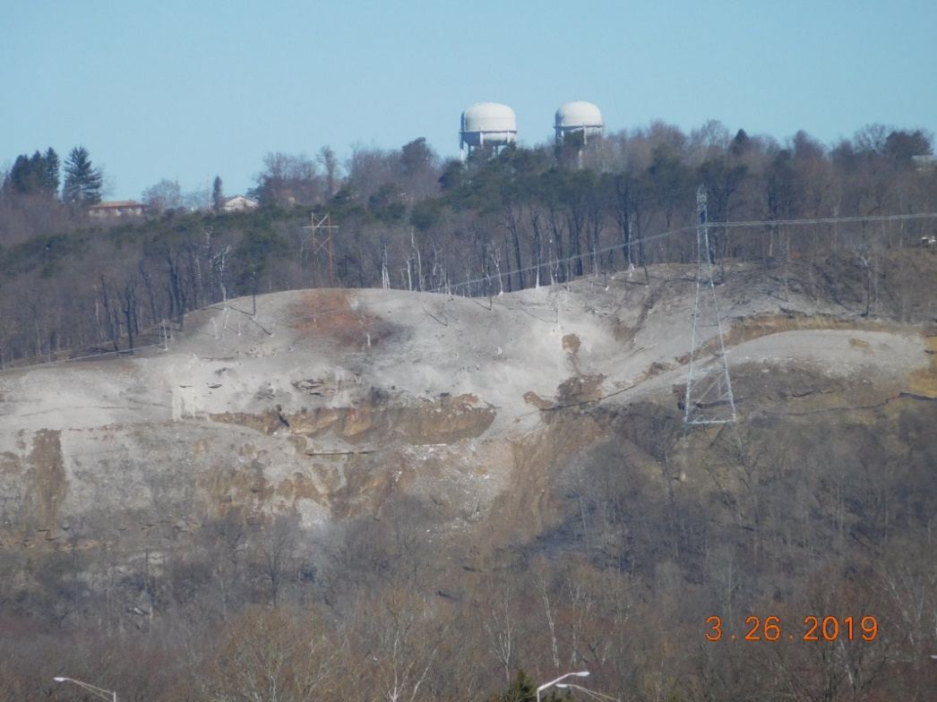
3-26-19 The explosion site now. Brown earth is unstable landslides, springs, erosion. A DEP report states, “The area does not appear capable of resisting erosion.”
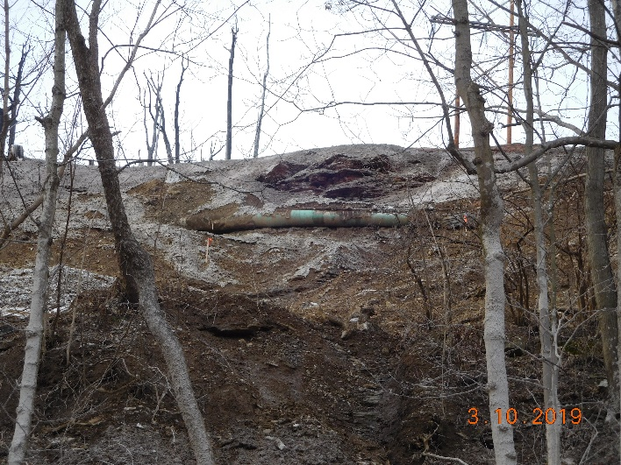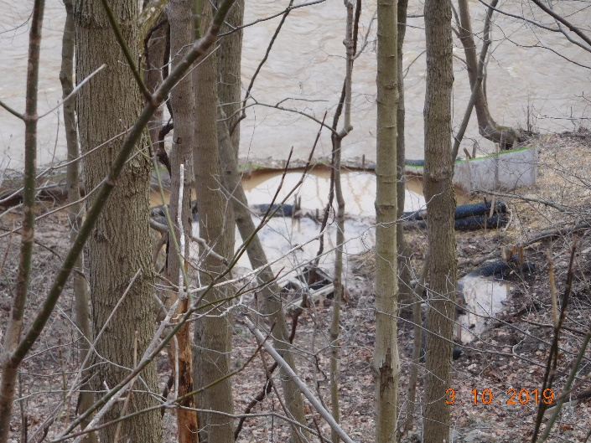
Left: 03-10-19 The hillside under the Energy Transfer pipeline, sliding towards Raccoon Creek.
Right: 03-10-19 An attempt to stop discharge into waterways of the Commonwealth. Raccoon Creek is a popular fishing and recreational waterway that is experiencing sediment discharges from the hillside.

